Oracle Access Management Administration Host (IDM Single Node) - Blueprint Information

# Overview

The purpose of this document is to describe the Oracle Access Management Administration Host blueprint (as part of the IDM Single Node blueprint) in detail. The goal of the blueprint is to allow for provisioning and configuration of a single node Oracle Access Management Administration Host (OAM AH) instance in an automated and repeatable fashion.

The following components and versions are installed as part of the OAM AH instance:

1. OAM Identity Server (OAM IS) Release 10.1.4.2.0.11 BP 11
2. Oracle HTTP Server (OHS) 10.1.3.0.0
3. OAM WebPass (OAM WP) Release 10.1.4.2.0.09 BP 09
4. OAM Policy Manager (OAM PM) Release 10.1.4.2.0.01 BP 01
5. OAM Access Server (OAM AS) Release 10.1.4.2.0.11 BP 11

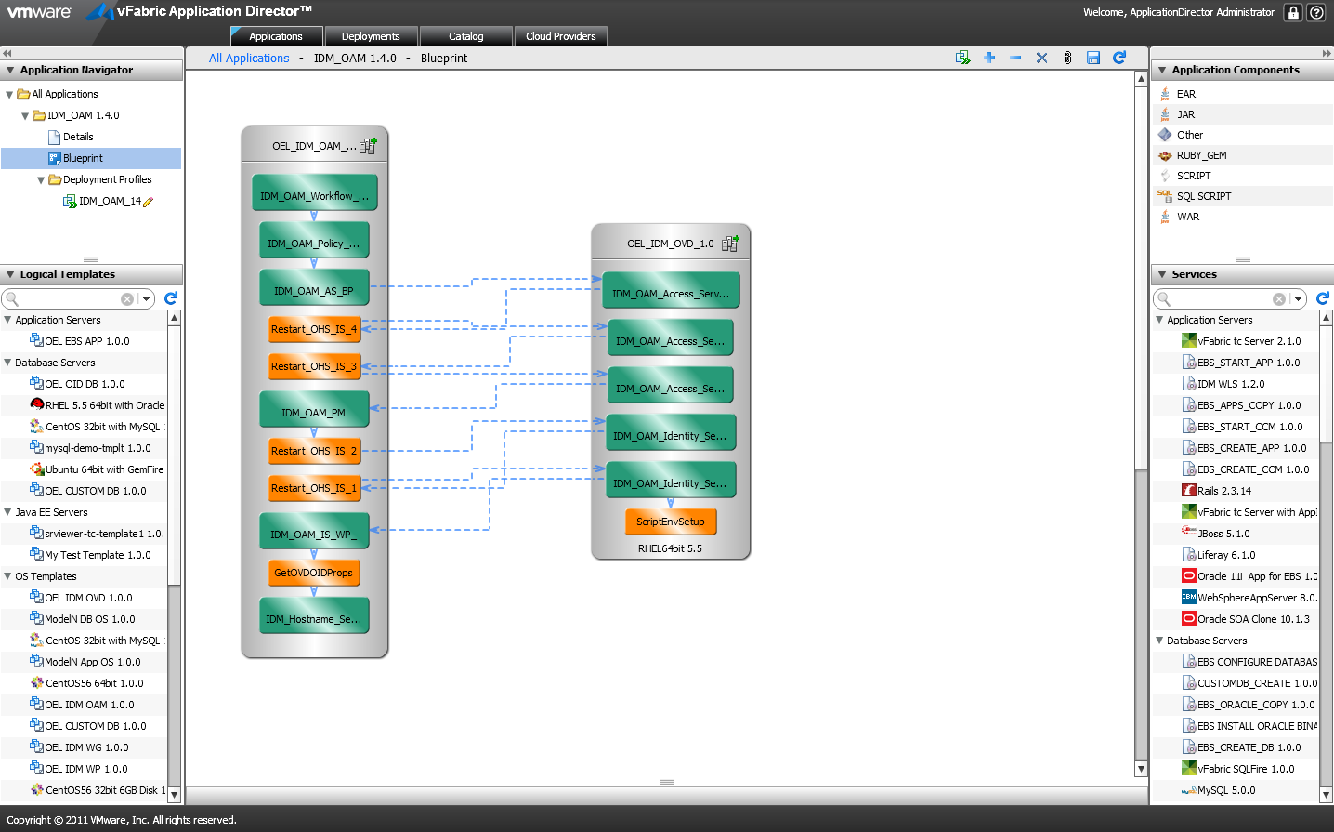

# High level BLUEPRINT Design

Conceptually, the blueprint design consists of the tasks described below. These tasks are listed in chronological order:

1. Setup Host Name (OAM Server Node)
2. Retrieve OVD and OID Properties (OAM Server Node)
3. Install OAM IS, OHS & OAM WP (OAM Server Node)
4. Setup Environment to run Selenium Scripts (OAM Configuration Node)
5. Setup OAM Identity System Part One (OAM Configuration Node)
6. Restart OHS and OAM IS (OAM Server Node)
7. Setup OAM Identity System Part Two (OAM Configuration Node)
8. Restart OHS and OAM IS (OAM Server Node)
9. Install OAM PM (OAM Server Node)
10. Setup OAM Access System Part One (OAM Configuration Node)
11. Restart OHS and OAM IS (OAM Server Node)
12. Setup OAM Access System Part Two (OAM Configuration Node)
13. Restart OHS and OAM IS (OAM Server Node)
14. Create OAM Access Server Definition (OAM Configuration Node)
15. Install OAM AS; Upgrade and apply patches to OAM IS, WP, PM and AS (OAM Server Node)
16. Import OAM Customized Policy (OAM Server Node)
17. Setup OAM Customized Workflow (OAM Server Node)

## Files

You will need access to create the following file repository that contains the necessary installers and configuration files needed. We will refer to this repository as the “Mount Point Location” in this document.

$MOUNTPOINTLOCATION/IDM:

ohs/ Installation and configuration directory of OHS 10.1.3.0.0

soa_linux_x86_101310_disk1.cpio Installation package of OHS 10.1.3.0.0 (Note: this package needs to be extracted in the same directory)

Templates/ OHS installation and configuration templates

ohs_install.rsp OHS silent installation response file Template

rootsh_rsp.txt Response file when running “root.sh”

staticports.ini OHS port configuration file

oam/ Installation and configuration directory of OAM

oam_101401/ Installation packages of OAM 10.1.4.0.1

oam_101420_patchset/ Installation upgrade patches of OAM 10.1.4.2.0

oam_101420_BP / Installation bundle patches of OAM 10.1.4.2.0

gcc_lib/ GCC libraries required by OAM installation

selenium/ Selenium scripts for OAM AH configuration

classes/ Selenium java classes to configure OAM AH

lib/ Selenium java libraries to configure OAM AH

setup.properties Properties to setup OAM AH

Templates/ OAM AH installation and configuration templates

is_install_options.txt OAM IS silent installation response file Template

wp_install_options.txt OAM WP silent installation response file Template

pm_install_options.txt OAM PM silent installation response file Template

as_install_options.txt OAM AS silent installation response file Template

simpleCA.tar OAM Certificate package

opmn_fix.xml OHS environment fix XML

oraInst.loc Oracle installation location file

policy/ Customized OAM policy files

workflows/ Customized OAM workflow configuration files

oid/ Installation and configuration directory of OID

Templates/ OID installation and configuration templates

add_oam_service_accounts.ldif ldif file to add OAM service accounts

change_service_accounts_password.ldif ldif file to change OAM service accounts’ passwords

mod_OblixAnonymous_orcladmin.ldif ldif file to modify OAM user “OblixAnonymous” and “orcladmin”

OID_oblix_schema_delete.ldif ldif file to clean up OID oblix schema before installing OAM Policy Manager

OID_oblix_schema_index_delete.ldif ldif file to clean up OID oblix schema index before installing OAM Policy Manager

update_filter.ldif ldif file to update OAM search filter

perforce/Templates/ Perforce templates used for inter-blueprint communications

oam.properties OAM properties file

You will also need below files to configure the scripts and services within this blueprint. Please refer to the following sections for details and their corresponding script/service.

IDM_Hostname_Setup_INSTALL.txt

GetOVDOIDProps_INSTALL.txt

IDM_OAM_Access_Server_Definition_INSTALL.txt

IDM_OAM_Access_Setup_1_INSTALL.txt

IDM_OAM_Access_Setup_2_INSTALL.txt

IDM_OAM_AS_BP_CONFIGURE.txt

IDM_OAM_AS_BP_INSTALL.txt

IDM_OAM_Identity_Setup_1_INSTALL.txt

IDM_OAM_Identity_Setup_2_INSTALL.txt

IDM_OAM_IS_WP_CONFIGURE.txt

IDM_OAM_IS_WP_INSTALL.txt

IDM_OAM_PM_INSTALL.txt

IDM_OAM_Policy_Setup_INSTALL.txt

IDM_OAM_Workflow_Setup_INSTALL.txt

Restart_OHS_IS_INSTALL.txt

ScriptEnvSetup_INSTALL.txt

## Setup Host Name (OAM Server Node)

The “Setup Host Name (OAM Server Node)” task sets the hostname for the machine that’s provisioned. It’s defined as a blueprint service.

Properties:

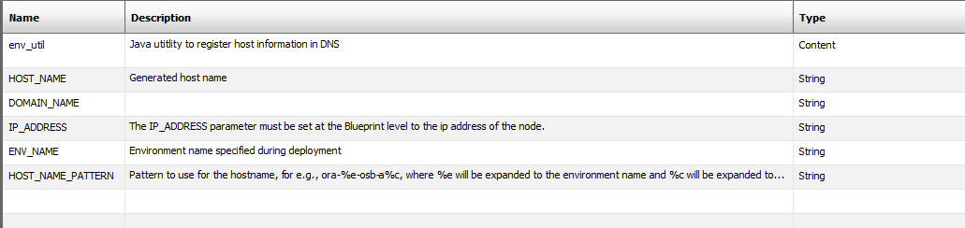

Actions:

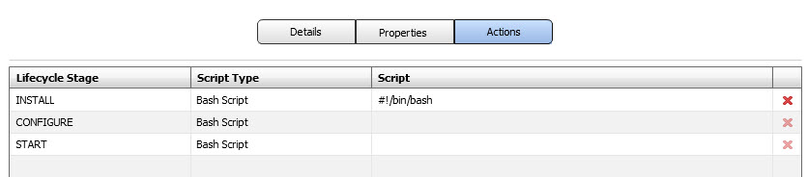

Install Script:

Please refer to file **IDM_Hostname_Setup_INSTALL.txt** to copy the script as the INSTALL Bash Script.

## Retrieve OVD and OID Properties (OAM Server Node)

The “Retrieve OVD and OID Properties (OAM Server Node)” task retrieves the OVD and OID information that OAM AH connects to from Perforce. It’s defined as a blueprint script.

Properties:

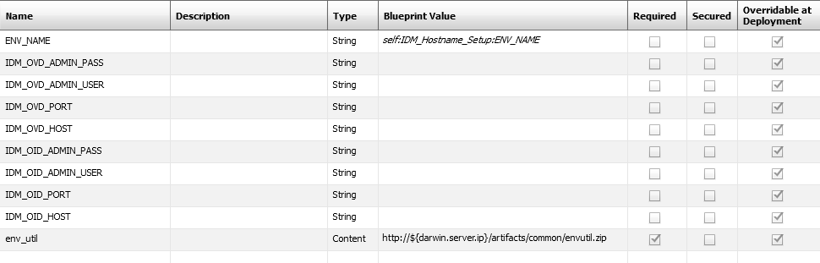

Actions:



Install Script:

Please refer to file **GetOVDOIDProps_INSTALL.txt** to copy the script as the INSTALL Bash Script.

## Install OAM IS, OHS & OAM WP (OAM Server Node)

The “Install OAM IS, OHS & OAM WP (OAM Server Node)” task installs an OAM IS server instance, an OHS instance along with an OAM WP server instance. It’s defined as a blueprint service.

Properties:

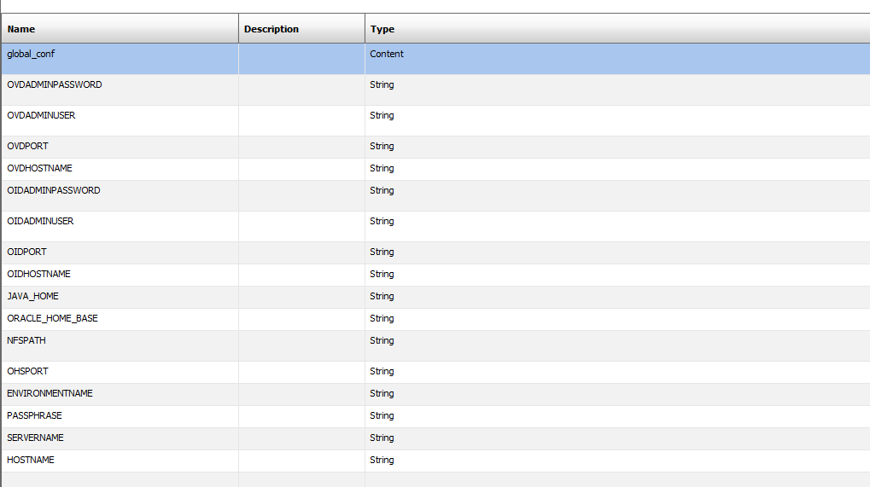

Actions:

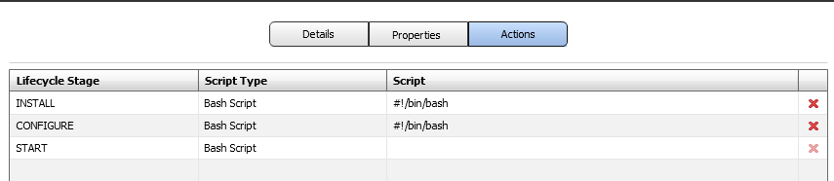

Install Script:

Please refer to file **IDM_OAM_IS_WP_INSTALL.txt** to copy the script as the INSTALL Bash Script.

Please refer to file **IDM_OAM_IS_WP_CONFIGURE.txt** to copy the script as the CONFIGURE Bash Script.

## Setup Environment to run Selenium Scripts (OAM Configuration Node)

The “Setup Environment to run Selenium Scripts (OAM Configuration Node)” task sets up OS environment in order to run Selenium scripts for OAM configuration. It’s defined as a blueprint script.

Properties:

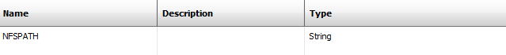

Actions:



Install Script:

Please refer to file **ScriptEnvSetup_INSTALL.txt** to copy the script as the INSTALL Bash Script.

## Setup OAM Identity System Part One (OAM Configuration Node)

The “Setup OAM Identity System Part One (OAM Configuration Node)” task is the part one of OAM Identity System configuration. It’s defined as a blueprint service.

Properties:

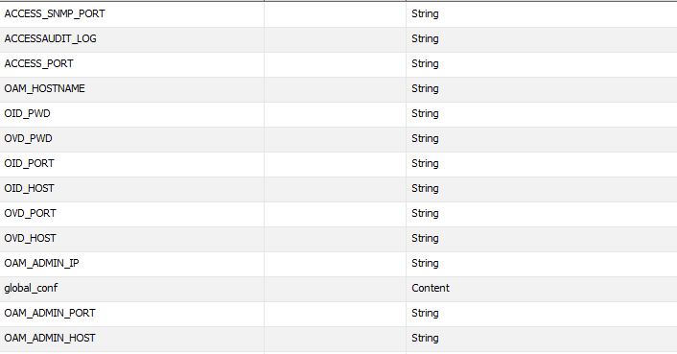

Actions:



Install Script:

Please refer to file **IDM_OAM_Identity_Setup_1_INSTALL.txt** to copy the script as the INSTALL Bash Script.

## Restart OHS and OAM IS (OAM Server Node)

The “Restart OHS and OAM IS (OAM Server Node)” task restarts OHS and OAM IS on OAM AH. It’s defined as a blueprint script.

Properties:

No property is required.

Actions:



Install Script:

Please refer to file **Restart_OHS_IS_INSTALL.txt** to copy the script as the INSTALL Bash Script.

## Setup OAM Identity System Part Two (OAM Configuration Node)

The “Setup OAM Identity System Part Two (OAM Configuration Node)” task is the part two of OAM Identity System configuration. It’s defined as a blueprint service.

Properties:

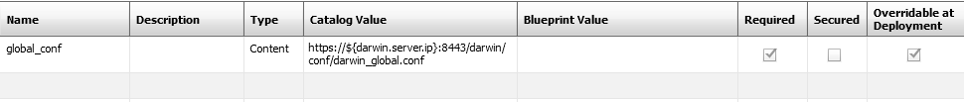

Actions:



Install Script:

Please refer to file **IDM_OAM_Identity_Setup_2_INSTALL.txt** to copy the script as the INSTALL Bash Script.

## Restart OHS and OAM IS (OAM Server Node)

Please refer to “2.7 Restart OHS and OAM IS (OAM Server Node)”.

## Install OAM PM (OAM Server Node)

The “Install OAM PM (OAM Server Node)” task installs an OAM PM server instance. It’s defined as a blueprint service.

Properties:

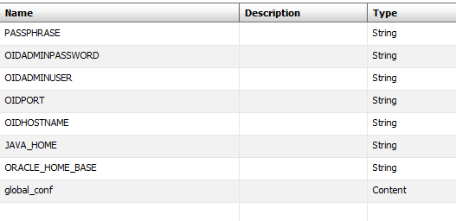

Actions:



Install Script:

Please refer to file **IDM_OAM_PM_INSTALL.txt** to copy the script as the INSTALL Bash Script.

## Setup OAM Access System Part One (OAM Configuration Node)

The “Setup OAM Access System Part One (OAM Configuration Node)” task is the part one of OAM Access System configuration. It’s defined as a blueprint service.

Properties:



Actions:



Install Script:

Please refer to file **IDM_OAM_Access_Setup_1_INSTALL.txt** to copy the script as the INSTALL Bash Script.

## Restart OHS and OAM IS (OAM Server Node)

Please refer to “2.7 Restart OHS and OAM IS (OAM Server Node)”.

## Setup OAM Access System Part Two (OAM Configuration Node)

The “Setup OAM Access System Part Two (OAM Configuration Node)” task is the part two of OAM Access System configuration. It’s defined as a blueprint service.

Properties:



Actions:



Install Script:

Please refer to file **IDM_OAM_Access_Setup_2_INSTALL.txt** to copy the script as the INSTALL Bash Script.

## Restart OHS and OAM IS (OAM Server Node)

Please refer to “2.7 Restart OHS and OAM IS (OAM Server Node)”.

## Create OAM Access Server Definition (OAM Configuration Node)

The “Create OAM Access Server Definition (OAM Configuration Node)” task is to create an OAM Access Server definition. It’s defined as a blueprint service.

Properties:



Actions:



Install Script:

Please refer to file **IDM_OAM_Access_Server_Definition_INSTALL.txt** to copy the script as the INSTALL Bash Script.

## Install OAM AS; Upgrade and apply patches to OAM IS, WP, PM and AS (OAM Server Node)

The “install OAM AS; Upgrade and apply patches to OAM IS, WP, PM and AS (OAM Server Node)” task installs an OAM AS server instance, upgrades and applies patches to the existing OAM IS, WP, PM and AS server instances. It’s defined as a blueprint service.

Properties:

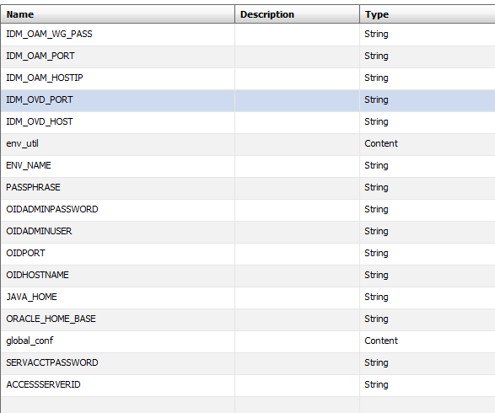

Actions:



Install Script:

Please refer to file **IDM_OAM_AS_BP_INSTALL.txt** to copy the script as the INSTALL Bash Script.

Please refer to file **IDM_OAM_AS_BP_CONFIGURE.txt** to copy the script as the CONFIGURE Bash Script.

## Import OAM Customized Policy (OAM Server Node)

The “Import OAM Customized Policy (OAM Server Node)” task is to import OAM customized policy. It’s defined as a blueprint service.

Properties:

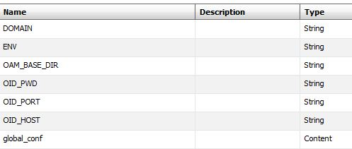

Actions:



Install Script:

Please refer to file **IDM_OAM_Policy_Setup_INSTALL.txt** to copy the script as the INSTALL Bash Script.

## Setup OAM Customized Workflow (OAM Server Node)

The “Setup OAM Customized Workflow (OAM Server Node)” task is to set up OAM customized workflow. It’s defined as a blueprint service.

Properties:

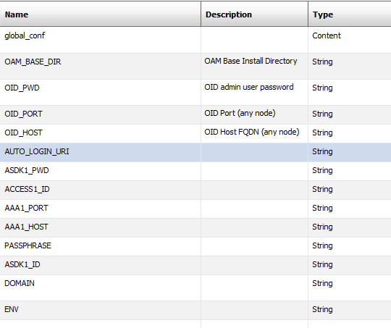

Actions:



Install Script:

Please refer to file **IDM_OAM_Workflow_Setup_INSTALL.txt** to copy the script as the INSTALL Bash Script.